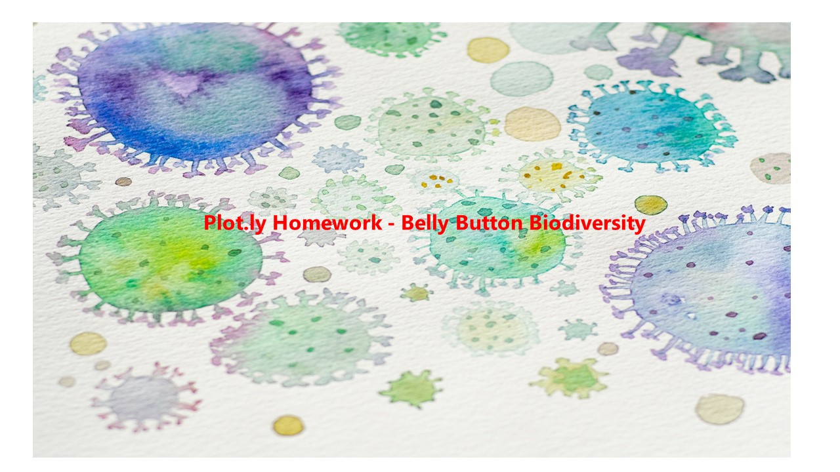

Photo by [Elena Mozhvilo](https://unsplash.com/@miracleday?utm_source=unsplash&utm_medium=referral&utm_content=creditCopyText) on [Unsplash](https://unsplash.com/?utm_source=unsplash&utm_medium=referral&utm_content=creditCopyText)

**Requirements**

The overall requirements for this homework are as follows: -

“In this assignment, you will build an interactive dashboard to explore the [Belly Button Biodiversity dataset](http://robdunnlab.com/projects/belly-button-biodiversity/), which catalogs the microbes that colonise human navels.

The dataset reveals that a small handful of microbial species (also called operational taxonomic units, or OTUs, in the study) were present in more than 70% of people, while the rest were relatively rare.”

The full details of the requirements for this homework can be found at:

<https://monash.bootcampcontent.com/monash-coding-bootcamp/monu-virt-data-11-2021-u-c/-/tree/master/02-Homework/15-Interactive-Visualizations-and-Dashboards/Instructions>

**Author: Mike Murphy**

**Tackling the Assignment**

**The Assignment was conducted in two parts. Each part has been deployed separately to Github pages at the following links:**

1. **Plotly** [**https://mikemurf.github.io/15-Plotly-Step-1-Homework/**](https://mikemurf.github.io/15-Plotly-Step-1-Homework/)
2. **Advanced Challenge Assignment (Optional)**

[**https://mikemurf.github.io/15-Plotly-Advanced-Challenge-Homework/**](https://mikemurf.github.io/15-Plotly-Advanced-Challenge-Homework/)

**Step 1: Plotly - was the assignment minimum requirement to: -**

1. Use the D3 library to read in `samples.json`.
2. Create a horizontal bar chart with a dropdown menu to display the top 10 OTUs found in that individual.
3. Create a bubble chart that displays each sample.
4. Display the sample metadata, i.e., an individual's demographic information.
5. Display each key-value pair from the metadata JSON object somewhere on the page.
6. Update all of the plots any time that a new sample is selected.

**The Output from Step 1: Plotly is as follows:**

**Test Subject ID No.: 940 - Top Half – Screen 1**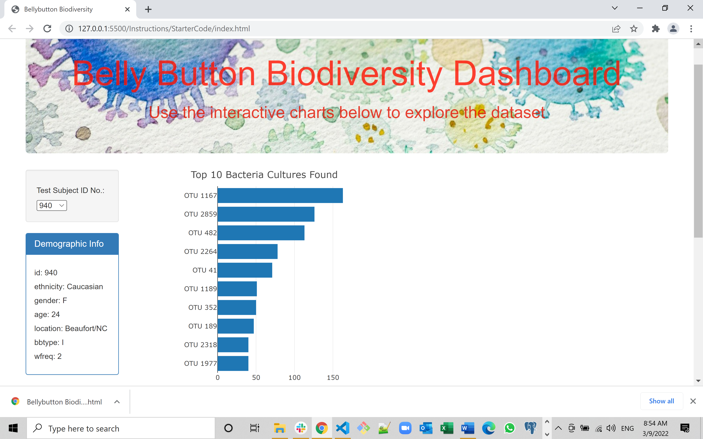

**Test Subject ID No.: 940 - Bottom Half – Screen 2**

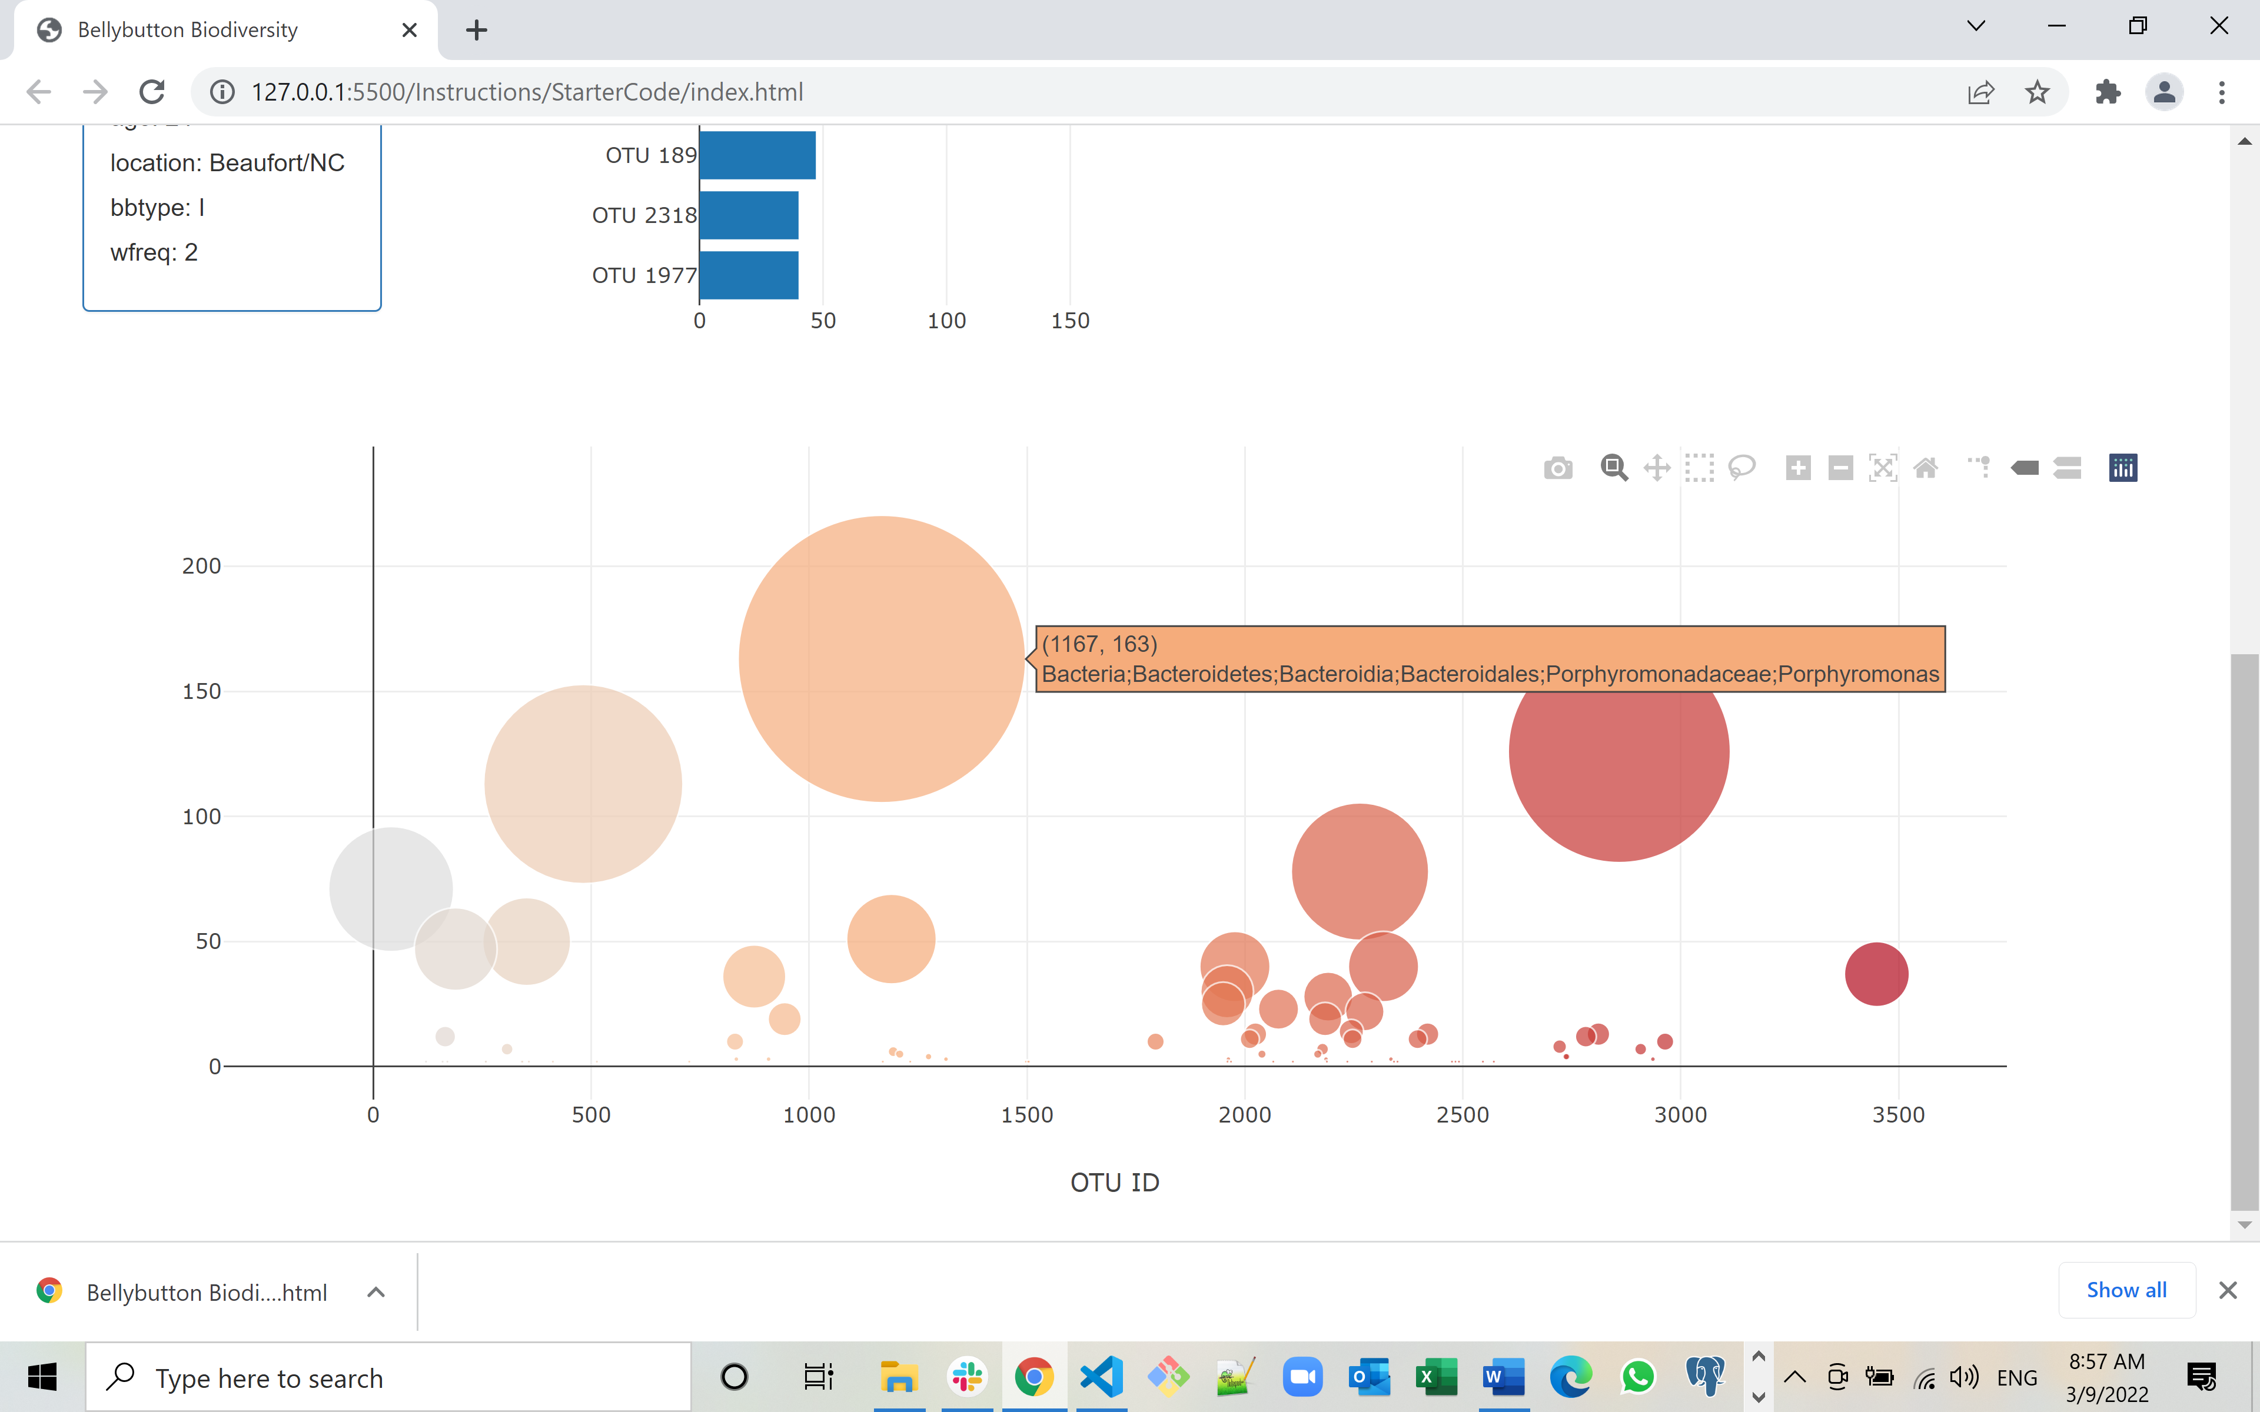 **Test Subject ID No.:**

**Test Subject ID No.: 955 - Top Half – Screen 1**

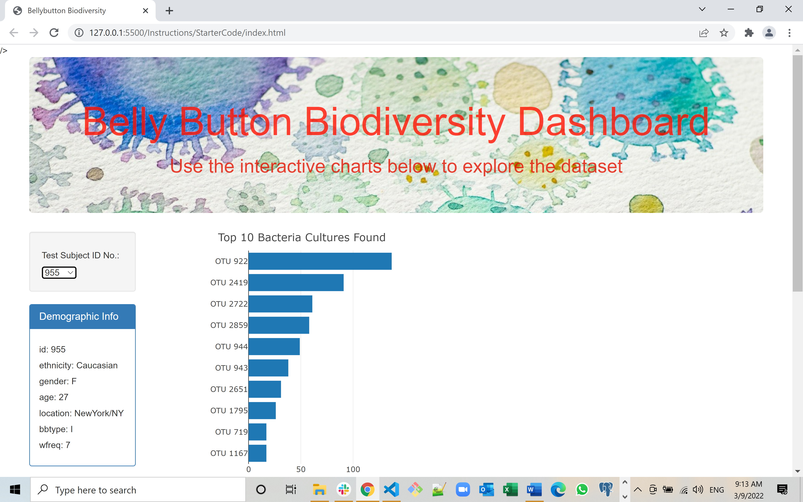

**Test Subject ID No.: 955 - Bottom Half – Screen 2**

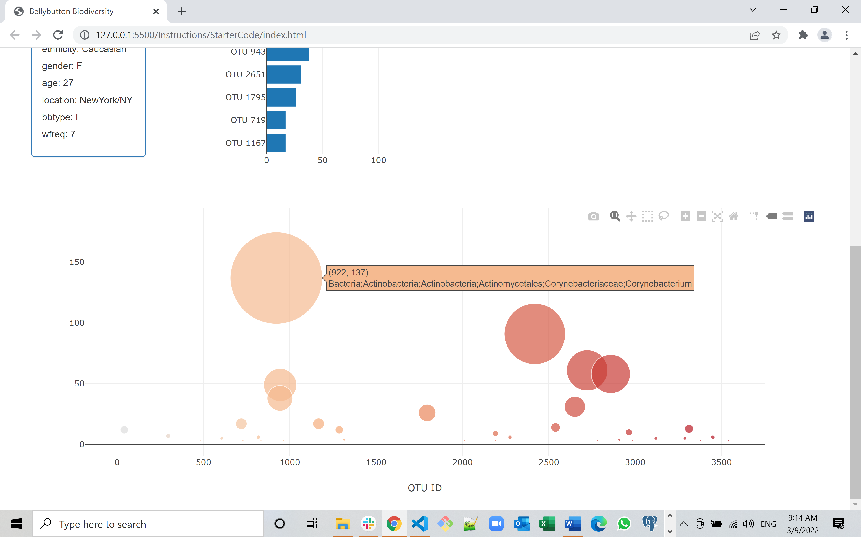

**Step 2: Advanced Challenge Assignment (Optional) requirement was to: -**

1. Adapt the Gauge Chart from <https://plot.ly/javascript/gauge-charts/> to plot the weekly washing frequency of the individual.
2. You need to modify the example gauge code to account for values ranging from 0 through 9.
3. Update the chart whenever a new sample is selected.

**The Output from Step 2: Advanced Challenge is as follows:**

**Test Subject ID No.: 940 - Top Half – Screen 1**

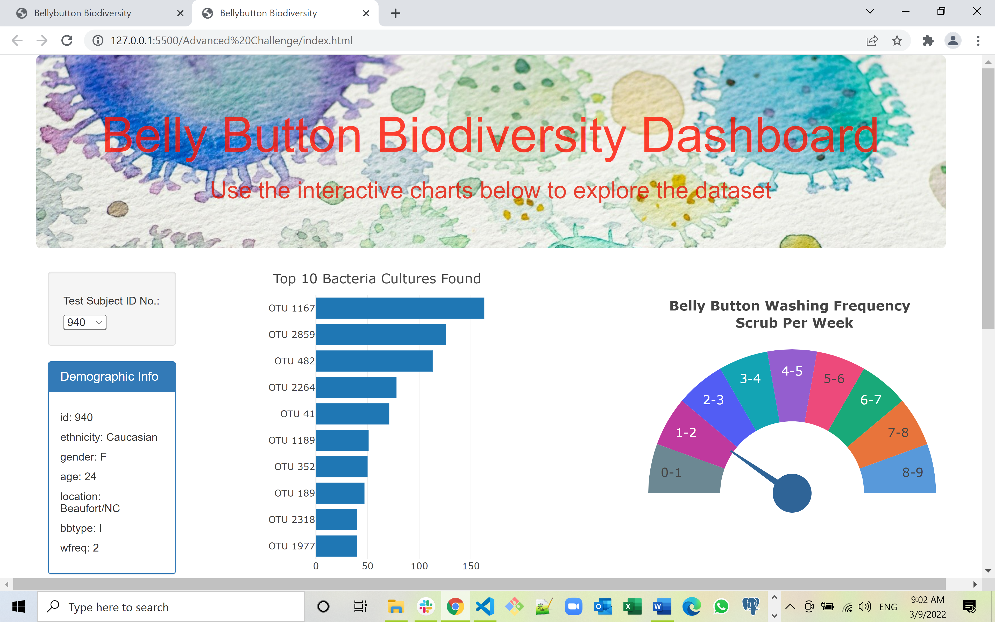

**Test Subject ID No.: 940 - Bottom Half – Screen 2**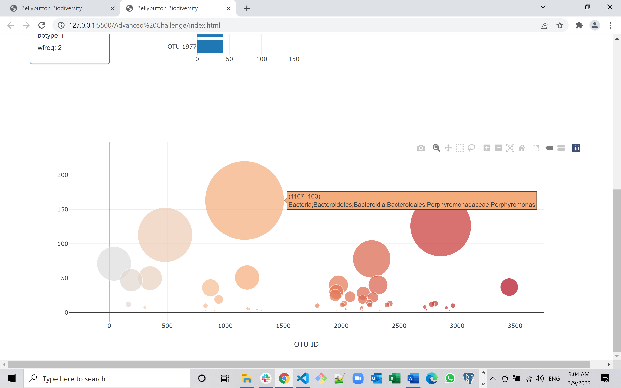

**Test Subject ID No.: 955 - Top Half – Screen 1**

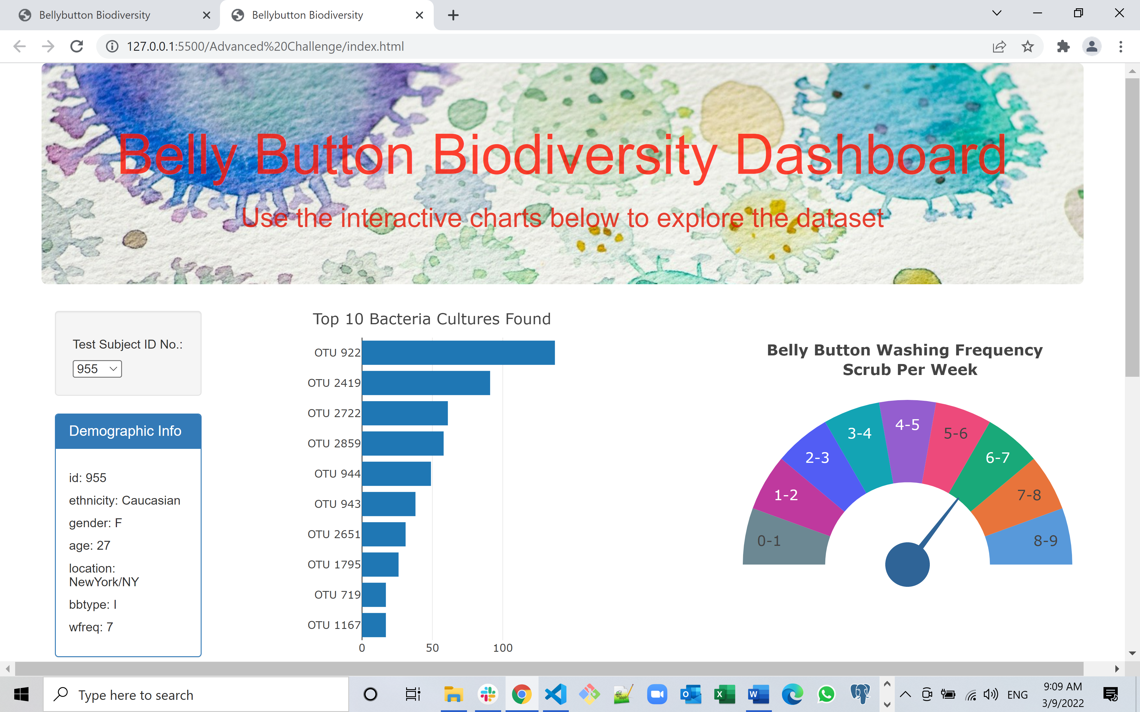

**Test Subject ID No.: 955 - Bottom Half – Screen 2**

